1. Main page

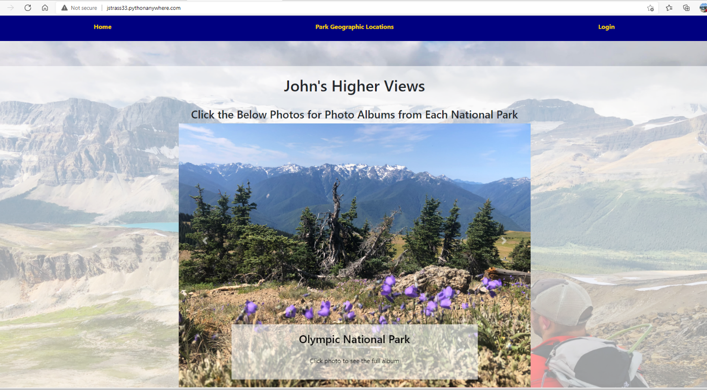

1. Login screen with button for signup

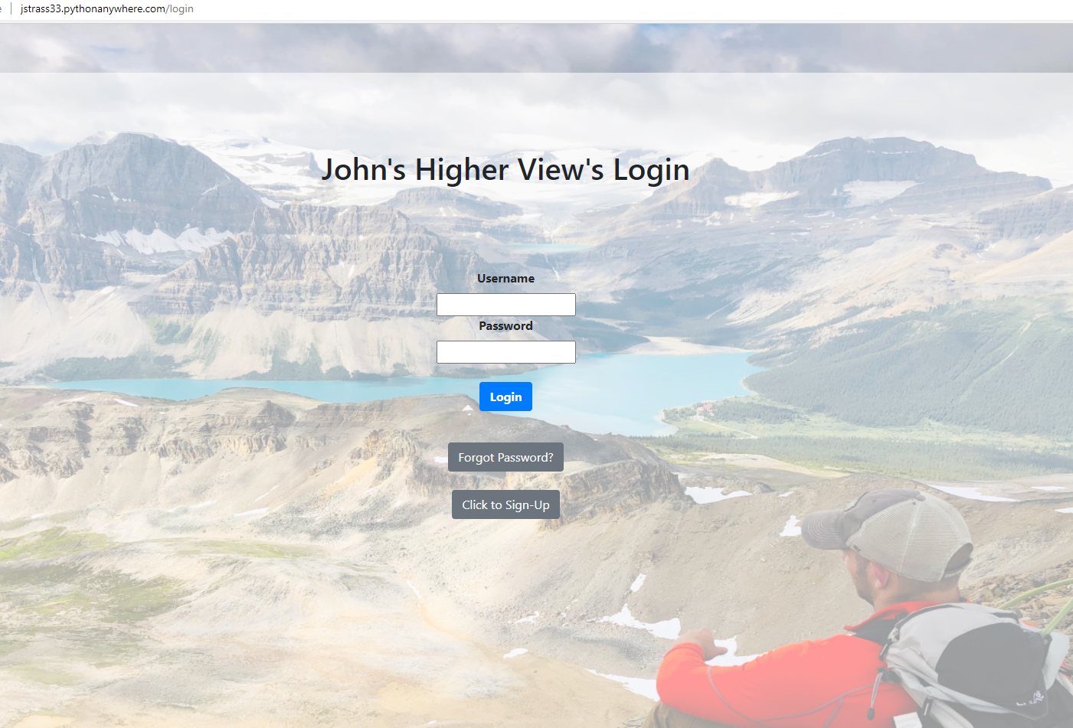

1. Sign-up screen

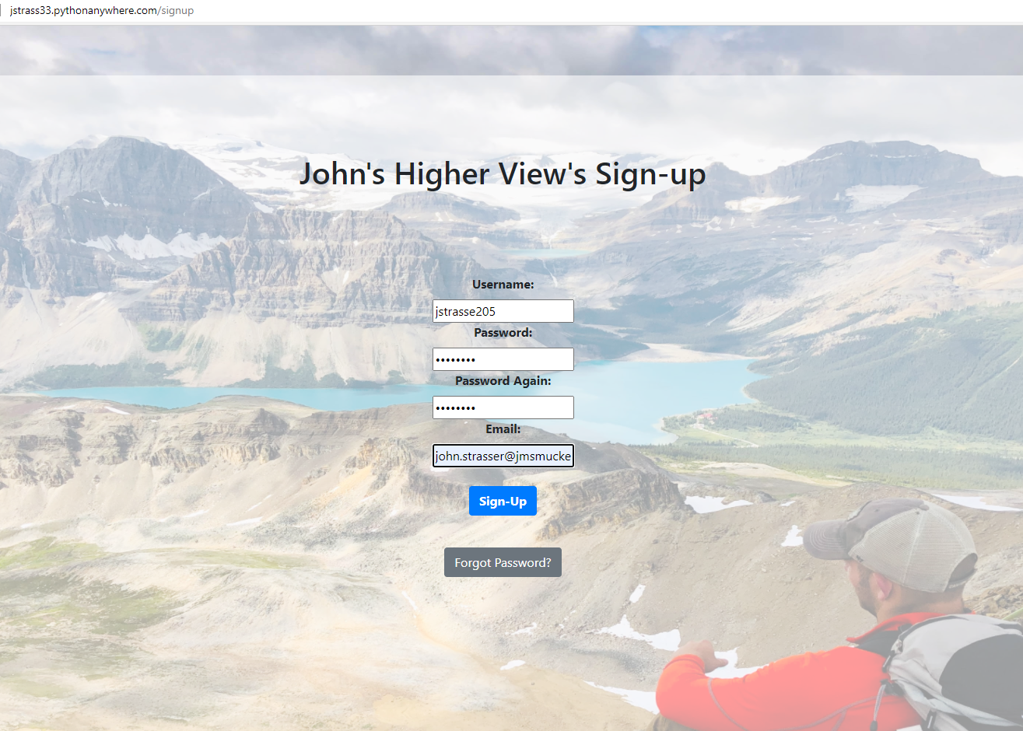

1. Main screen showing the current user logged in with the logout button available

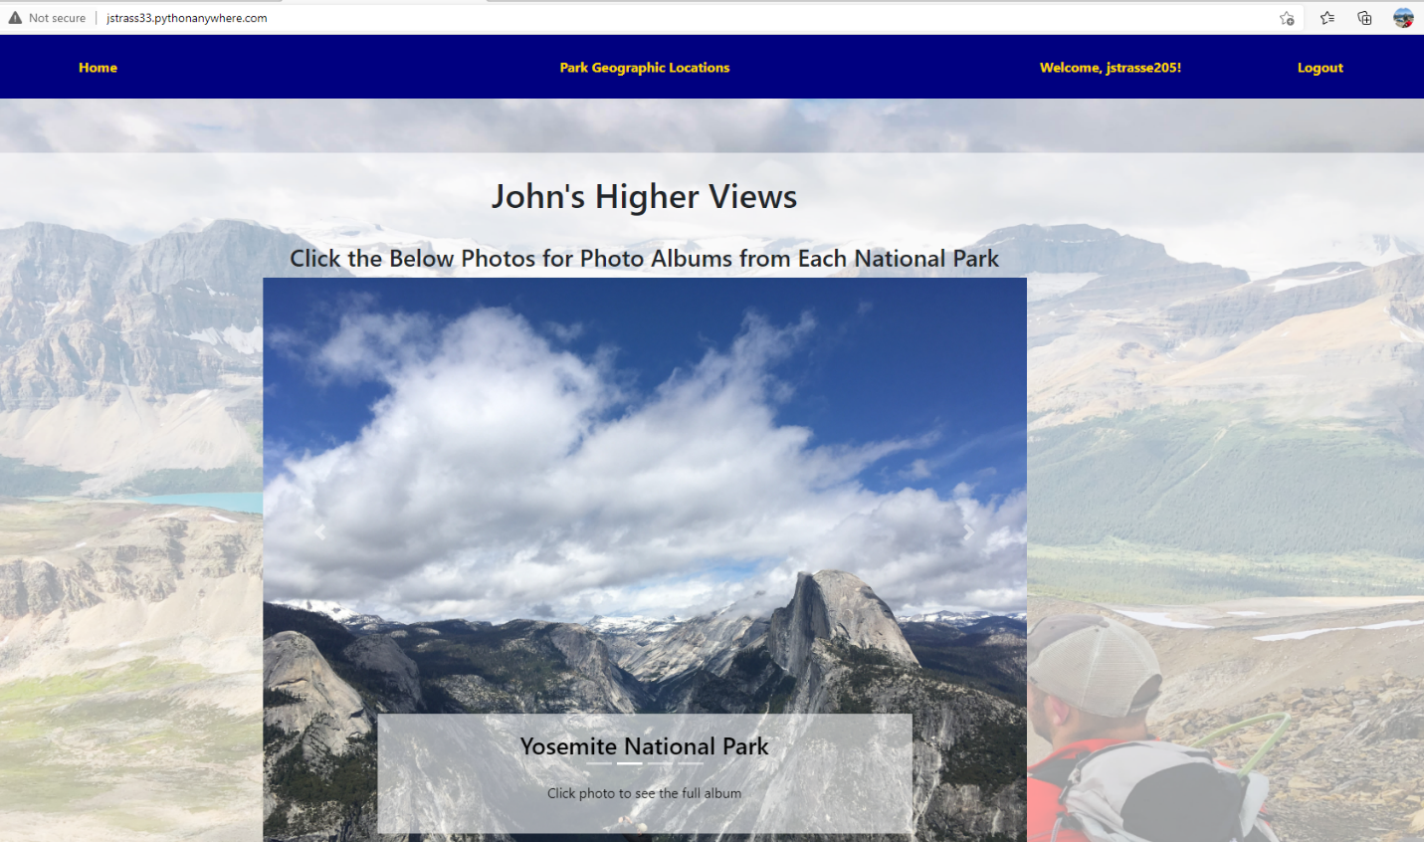

1. Clicked into photo album. Shows that the current user see other’s comments for this album, but can only delete their own.

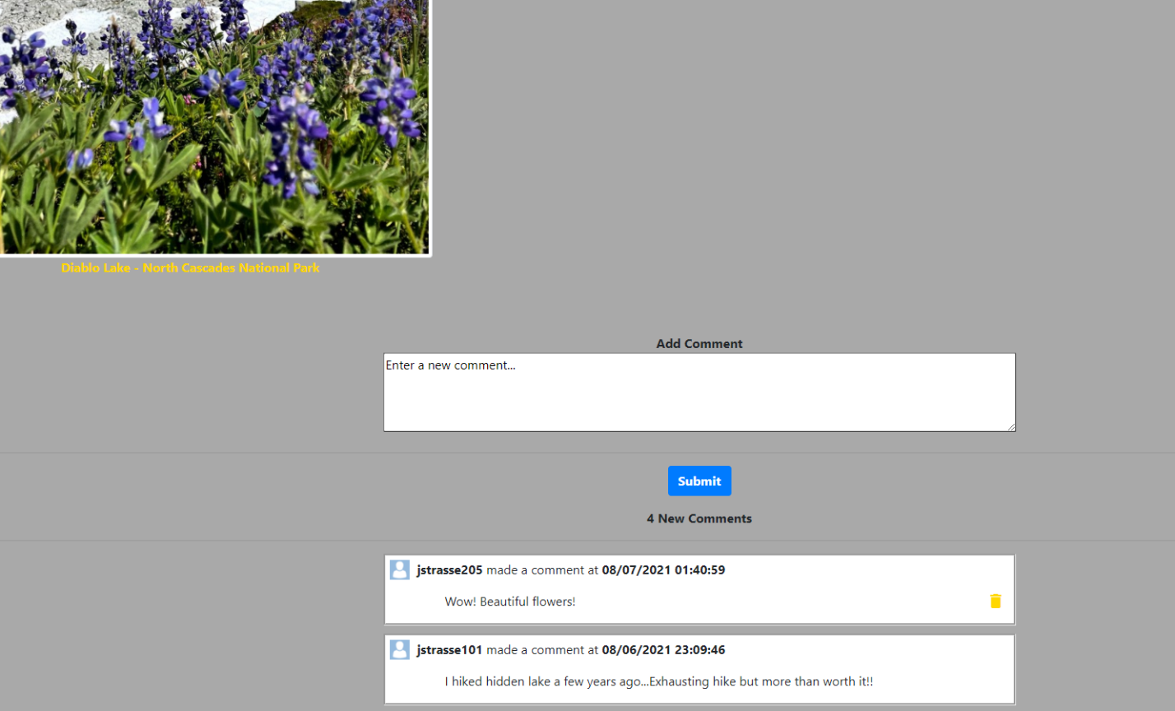

1. Clicked into the geographic locations tab. Lets you click buttons to zoom in on where different parks are.

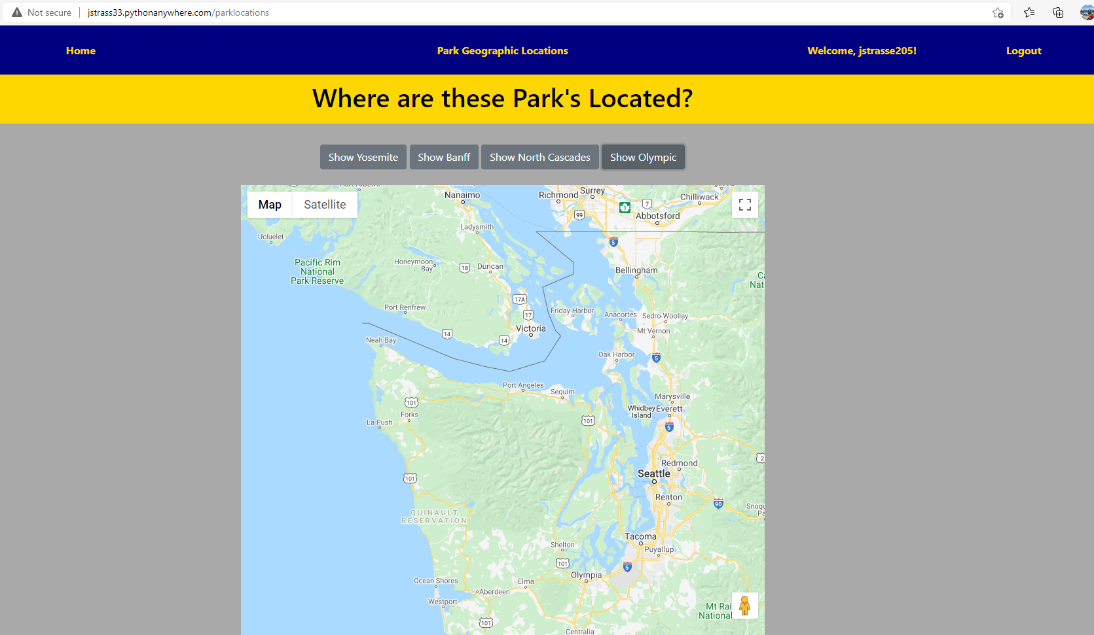

1. Clicked logout and it takes you back to the main page and doesn’t show a user in the top.

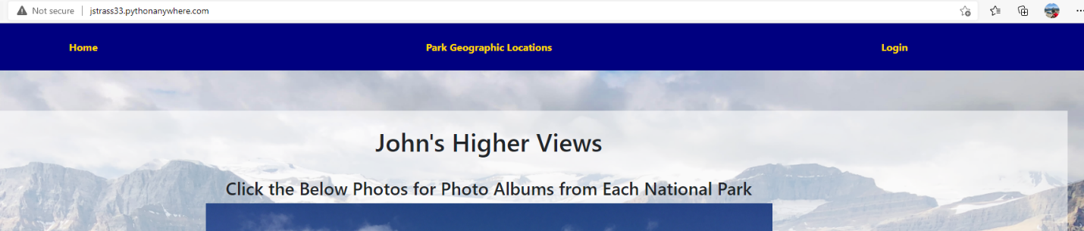

1. Went to login and clicked forgot password this time. It takes you to the following screen

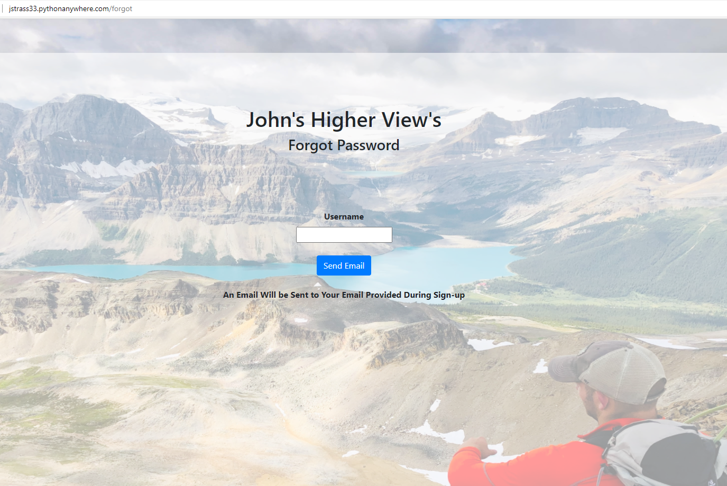

1. My inbox with the password reset and the email verification emails

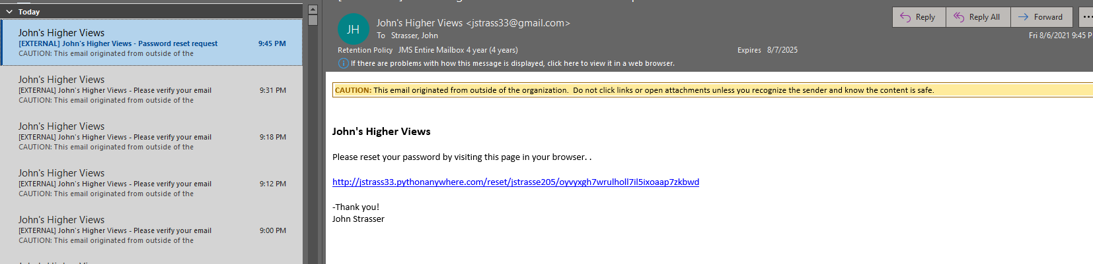

1. Clicking the link takes you to the reset page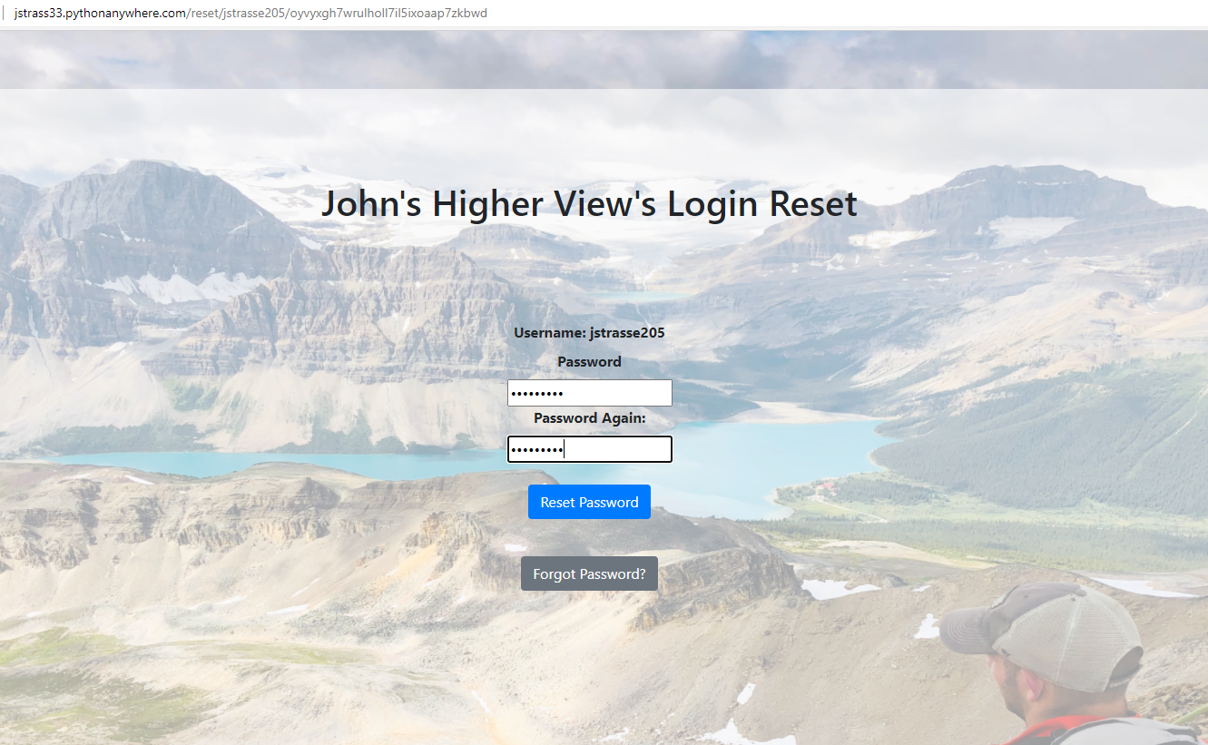
2. After the reset, I could then log back in with the new password

